Answers

# Activity 1 – Make a Square

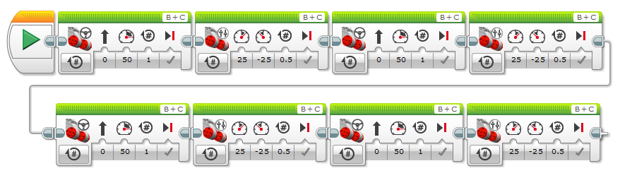

# Activity 2 – Square with a Loop



